Daniel Meyer

CSE 520

Tong Yu

**Lab 8 Report**

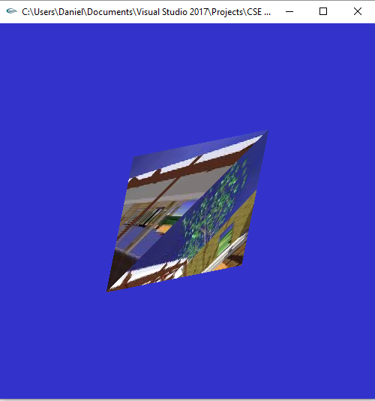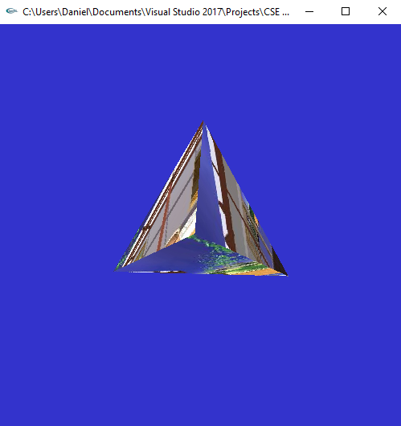

#include <stdlib.h>

#include <stdio.h>

#include <string.h>

//#include “imageio.h”

#include <SOIL/SOIL.h>

#include <GL/glut.h>

#define PI 3.14159265359

int texImageWidth;

int texImageHeight;

int window;

static GLuint texName[6]; //texture names

int anglex = 0, angley = 0, anglez = 0; //rotation angles

float xdiff = 0.0, ydiff = 0.0, zdiff = 0.0;

bool mouseDown = false;

char maps[][20] = { "cubemap_fr.png", "cubemap_bk.png", "cubemap_rt.png", "cubemap_lf.png",

"cubemap_up.png", "cubemap_dn.png" };

//load texture image

GLubyte *makeTexImage(char *loadfile)

{

int i, j, c, width, height;

GLubyte *texImage;

//texImage = loadImageRGBA( (char *) loadfile, &width, &height);

texImage = SOIL_load_image(loadfile, &width, &height, 0, SOIL_LOAD_RGBA);

texImageWidth = width;

texImageHeight = height;

return texImage;

}

void init(void)

{

glClearColor(0.2, 0.2, 0.8, 0.0);

glShadeModel(GL_FLAT);

glEnable(GL_DEPTH_TEST);

glPixelStorei(GL_UNPACK_ALIGNMENT, 1);

//texName is global

glGenTextures(6, texName);

for (int i = 0; i < 4; ++i) {

GLubyte *texImage = makeTexImage(maps[i]);

if (!texImage) {

printf("\nError reading %s \n", maps[i]);

continue;

}

glBindTexture(GL_TEXTURE_2D, texName[i]); //now we work on texName

glTexParameteri(GL_TEXTURE_2D, GL_TEXTURE_WRAP_S, GL_REPEAT);

glTexParameteri(GL_TEXTURE_2D, GL_TEXTURE_WRAP_T, GL_REPEAT);

glTexParameteri(GL_TEXTURE_2D, GL_TEXTURE_MAG_FILTER, GL_NEAREST);

glTexParameteri(GL_TEXTURE_2D, GL_TEXTURE_MIN_FILTER, GL_NEAREST);

glTexImage2D(GL_TEXTURE_2D, 0, GL_RGBA, texImageWidth,

texImageHeight, 0, GL_RGBA, GL_UNSIGNED_BYTE, texImage);

delete texImage; //free memory holding texture image

}

}

void display(void)

{

glClear(GL_COLOR_BUFFER_BIT | GL_DEPTH_BUFFER_BIT);

glEnable(GL_TEXTURE_2D);

glTexEnvf(GL_TEXTURE_ENV, GL_TEXTURE_ENV_MODE, GL_DECAL);

glEnable(GL_CULL_FACE);

glCullFace(GL_BACK);

glPushMatrix();

glRotatef(anglex, 1.0, 0.0, 0.0); //rotate the cube along x-axis

glRotatef(angley, 0.0, 1.0, 0.0); //rotate along y-axis

glRotatef(anglez, 0.0, 0.0, 1.0); //rotate along z-axis

glBindTexture(GL_TEXTURE_2D, texName[0]);

glBegin(GL_TRIANGLES);

//front triangle

glTexCoord2f(0.0, 0.0); glVertex3f(-1.0f, 1.0f, -1.0f);

glTexCoord2f(1.0, 0.0); glVertex3f(1.0f, -1.0f, -1.0f);

glTexCoord2f(0.0, 1.0); glVertex3f(-1.0f, -1.0f, 1.0f);

glEnd();

glBindTexture(GL_TEXTURE_2D, texName[1]);

glBegin(GL_TRIANGLES);

//right side triangle

glTexCoord2f(0.0, 0.0); glVertex3f(1.0f, 1.0f, 1.0f);

glTexCoord2f(1.0, 0.0); glVertex3f(-1.0f, -1.0f, 1.0f);

glTexCoord2f(0.0, 1.0); glVertex3f(1.0f, -1.0f, -1.0f);

glEnd();

glBindTexture(GL_TEXTURE_2D, texName[2]);

glBegin(GL_TRIANGLES);

//left side triangle

glTexCoord2f(0.0, 0.0); glVertex3f(1.0f, 1.0f, 1.0f);

glTexCoord2f(1.0, 0.0); glVertex3f(-1.0f, 1.0f, -1.0f);

glTexCoord2f(0.0, 1.0); glVertex3f(-1.0f, -1.0f, 1.0f);

glEnd();

glBindTexture(GL_TEXTURE_2D, texName[3]);

glBegin(GL_TRIANGLES);

//bottom triangle

glTexCoord2f(0.0, 0.0); glVertex3f(1.0f, 1.0f, 1.0f);

glTexCoord2f(1.0, 0.0); glVertex3f(1.0f, -1.0f, -1.0f);

glTexCoord2f(0.0, 1.0); glVertex3f(-1.0f, 1.0f, -1.0f);

glEnd();

glPopMatrix();

glFlush();

glDisable(GL_TEXTURE_2D);

}

void keyboard(unsigned char key, int x, int y)

{

switch (key) {

case 'x':

anglex = (anglex + 3) % 360;

break;

case 'X':

anglex = (anglex - 3) % 360;

break;

case 'y':

angley = (angley + 3) % 360;

break;

case 'Y':

angley = (angley - 3) % 360;

break;

case 'z':

anglez = (anglez + 3) % 360;

break;

case 'Z':

anglez = (anglez - 3) % 360;

break;

case 27: /* escape */

glutDestroyWindow(window);

exit(0);

}

glutPostRedisplay();

}

void mouse(int button, int state, int x, int y)

{

if (button == GLUT_LEFT_BUTTON && state == GLUT_DOWN)

{

mouseDown = true;

xdiff = x - angley;

ydiff = -y + anglex;

}

/*

//For XYZ rotation using different mouse buttons Pt.2

if (button == GLUT_LEFT_BUTTON && state == GLUT_DOWN)

{

//mouseDown = true;

mouseDown = 1;

xdiff = x - yrot;

//ydiff = -y + xrot;

}

else if (button == GLUT_RIGHT_BUTTON && state == GLUT_DOWN)

{

//mouseDown = true;

mouseDown = 2;

ydiff = -y + xrot;

}

else if (button == GLUT_MIDDLE_BUTTON && state == GLUT_DOWN)

{

mouseDown = 3;

//zdiff = x - zrot;

anglez += 5.0 * (PI / 180);

}

else

{

mouseDown = 0;

//mouseDown = false;

}

*/

}

void mouseMotion(int x, int y)

{

if (mouseDown == true)

{

angley = x - xdiff * (PI / 180);

anglex = y + ydiff * (PI / 180);

glutPostRedisplay();

}

/*

//For XYZ rotation using different mouse buttons Pt.3

if (mouseDown == 1)

{

yrot = x - xdiff * (PI / 180);

//xrot = y + ydiff * (PI / 180);

//glutPostRedisplay();

}

else if (mouseDown == 2)

{

xrot = y + ydiff * (PI / 180);

}

else if (mouseDown == 3)

{

zrot = x - zdiff * (PI / 180);

}

glutPostRedisplay();

*/

}

void reshape(int w, int h)

{

glViewport(0, 0, (GLsizei)w, (GLsizei)h);

glMatrixMode(GL_PROJECTION);

glLoadIdentity();

gluPerspective(60.0, (GLfloat)w / (GLfloat)h, 1.0, 30.0);

glMatrixMode(GL_MODELVIEW);

glLoadIdentity();

gluLookAt(0, 0, 5, 0, 0, 0, 0, 1, 0);

}

int main(int argc, char** argv)

{

glutInit(&argc, argv);

glutInitDisplayMode(GLUT_SINGLE | GLUT_RGB | GLUT_DEPTH);

glutInitWindowSize(500, 500);

glutInitWindowPosition(100, 100);

window = glutCreateWindow(argv[0]);

init();

glutDisplayFunc(display);

glutReshapeFunc(reshape);

glutKeyboardFunc(keyboard);

glutMouseFunc(mouse);

glutMotionFunc(mouseMotion);

glutMainLoop();

return 0;

}

**Summary:**

This assignment was similar to Part 1 of Homework 3, but with a different object type. Instead of creating a 6-sided textured cube we were to create a 4-sided Tetrahedron which involves triangles. As such I modified the code used for Homework 3 to use only 4 different images as opposed to 6, changed the object type to triangles instead of quads, and finally changed the texture coordinates to match a triangle (using only 3 as opposed to 4). Overall, the program compiled and ran correctly with both key and mouse rotation and I feel I have earned the full 20 points for the assignment.